ICIN Bank
(AN ONLINE BANKING WEB APP)
GITHUB LINK: https://github.com/AnishAugustin09/ICIN-BANK
This document contains the:
- Sprint Planning
- Flow of Project
- Concepts used in Project
- Working on Eclipse IDE
- Conclusion

Sprint Planning:
For this project, I’ve planned to complete the project in 4 Sprints. And the task is completed according to that. And This is a Full Stack Java Project so Backend & Frontend Technologies used here.
Features:
Admin Portal:
It deals with all the back-end data generation and product information. The admin user should be able to:
• Authorize the roles and guidelines for the user
• Grant access to the user regarding money transfer, deposits, and withdrawal
• Block the user account in case of any threat
• Authorize the cheque book requests
User Portal:
It deals with the user activities. The user should be able to:
• Register or log in to the application to maintain a record of activities
• Deposit and withdraw money from the account
• View transactions and balance in the primary and savings account
• Transfer funds between different accounts and add recipients
• Request cheque books for different accounts
User Flow of Project:
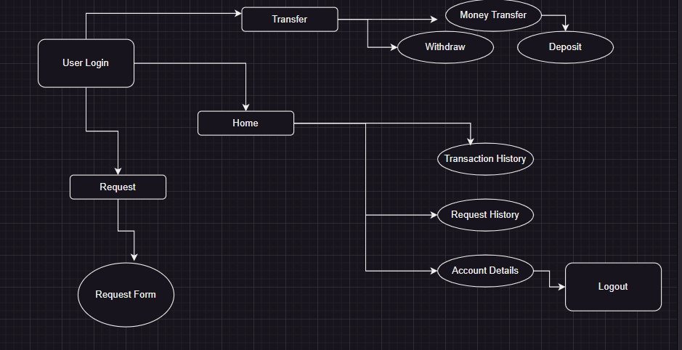

Admin Flow of Project:
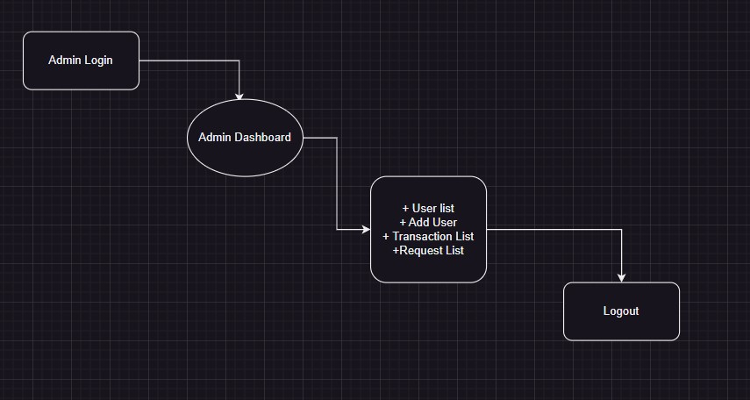

VS Code:
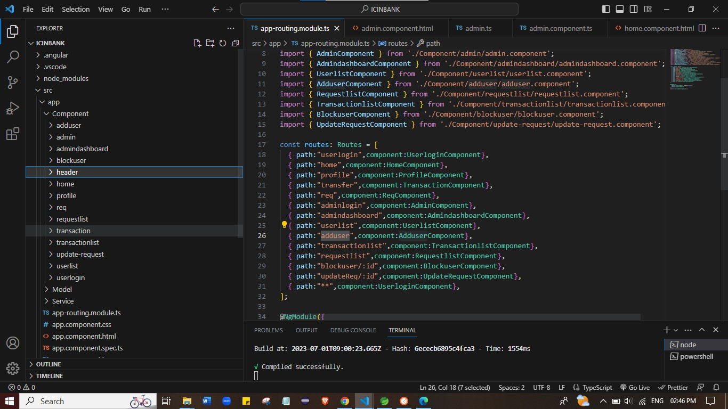

Spring Boot:
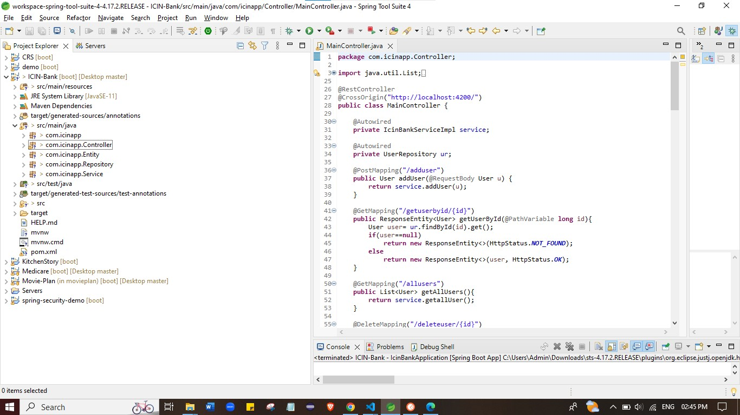
Concepts used in Project:
- HTML, CSS & JS
- ANGULAR
- JAVA , API, MAVEN
- SQL DATABASE
- SPRING TOOL SUITE 4
- Tomcat Server 9.0
- Git & Github
- POSTMAN
- VS Code

Login page:
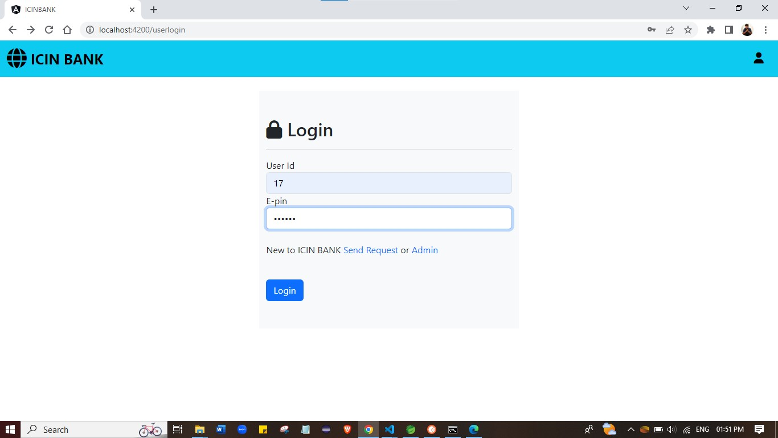

Login validation:
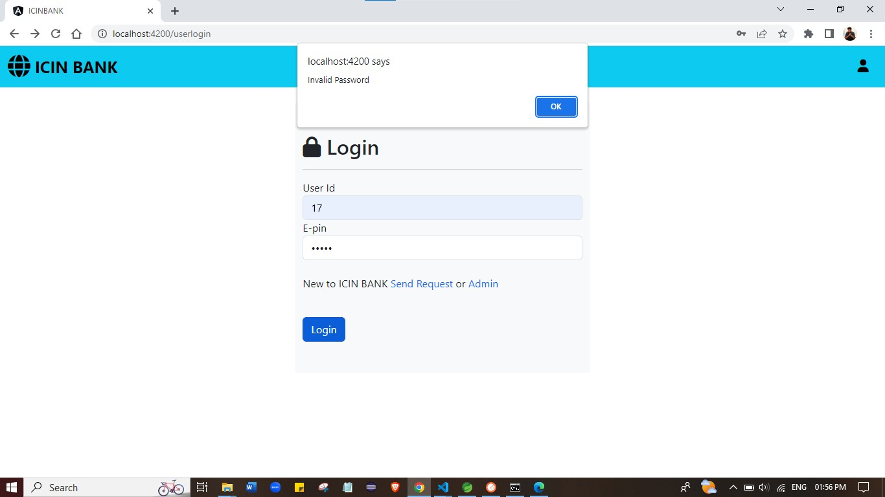

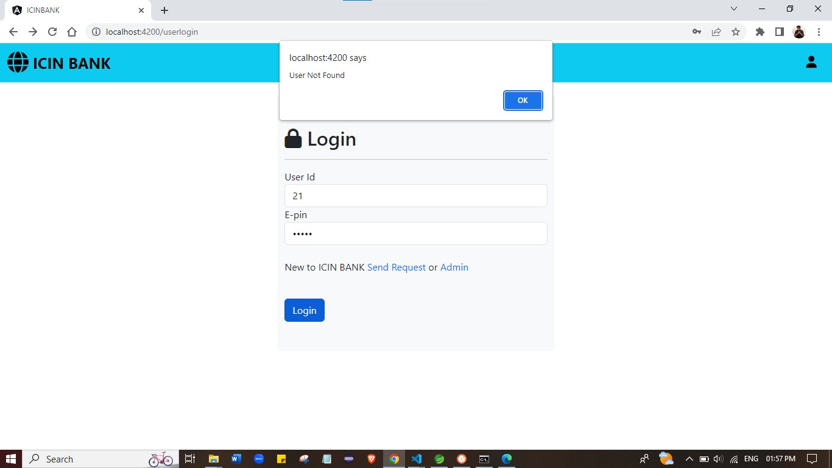

Register page:
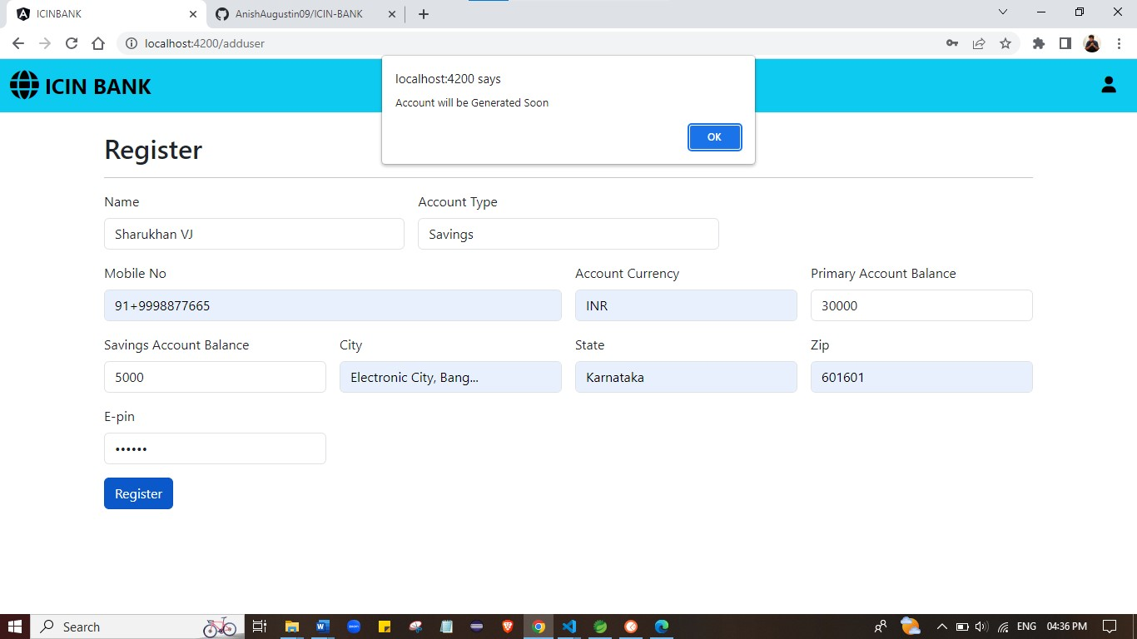

Home page:
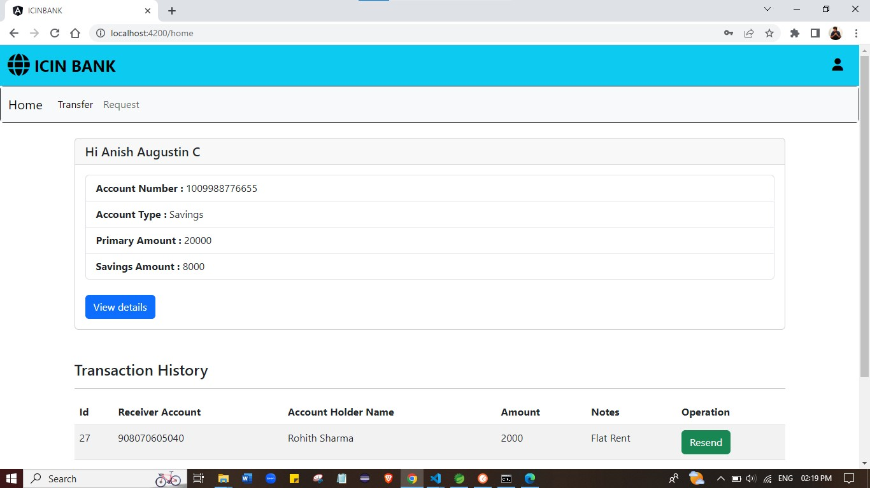
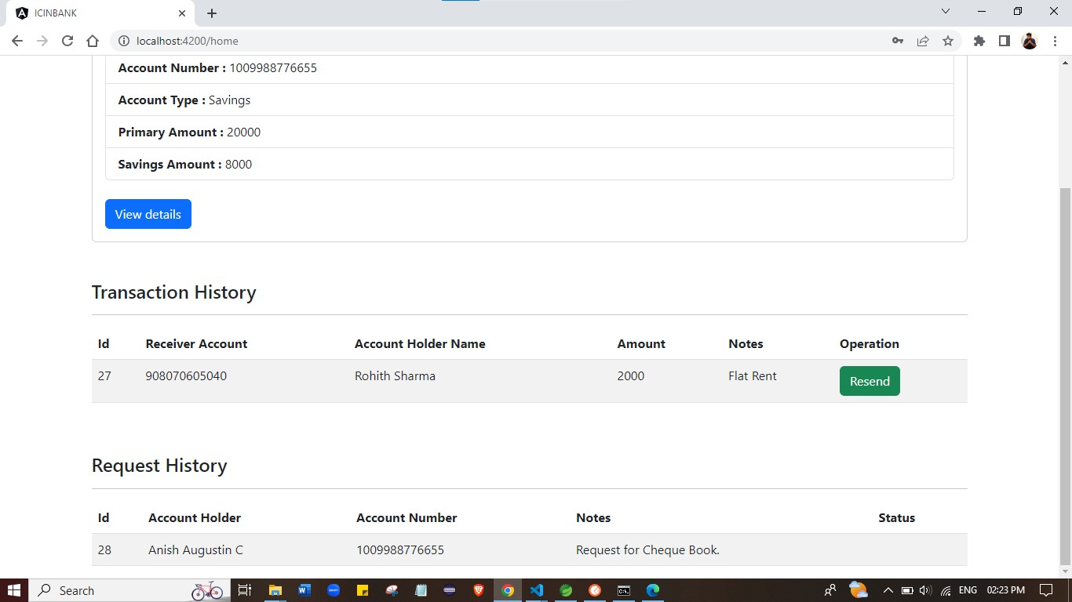

Profile:
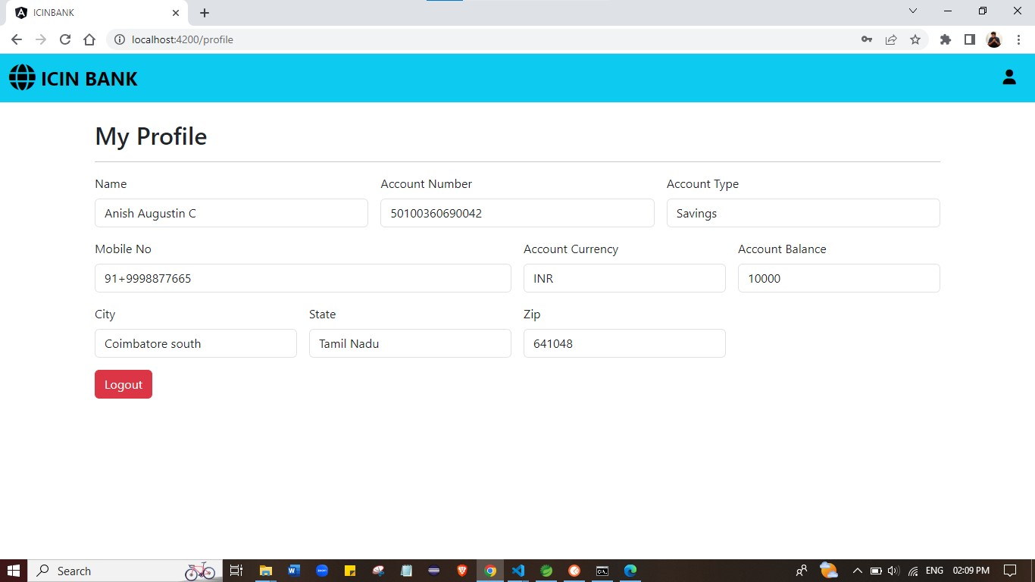

Logout:
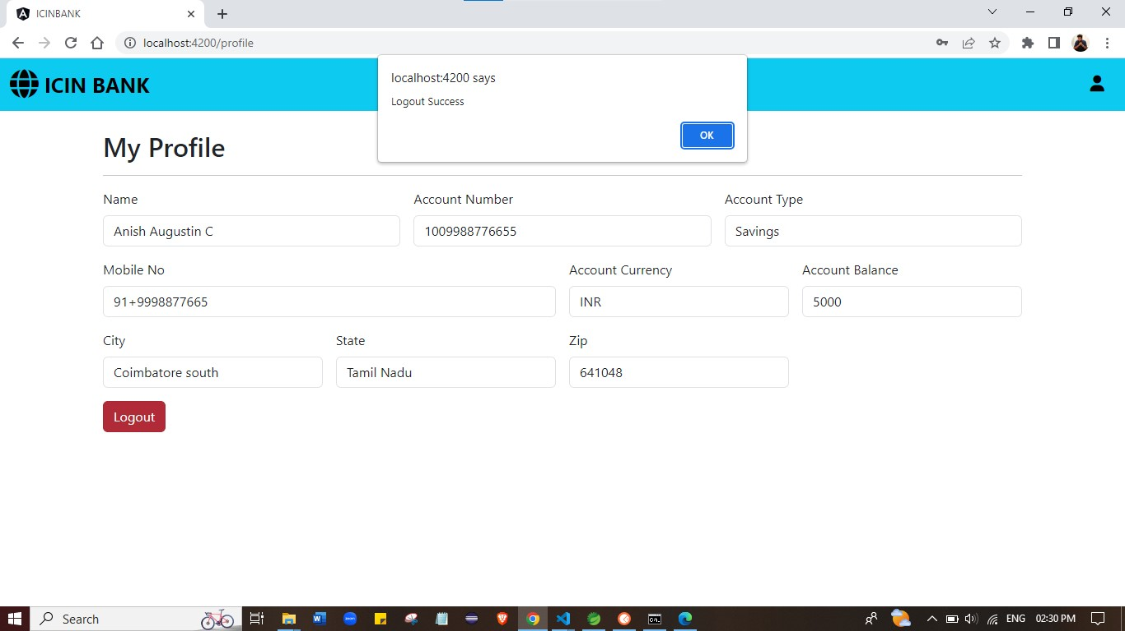

Money Transfer :
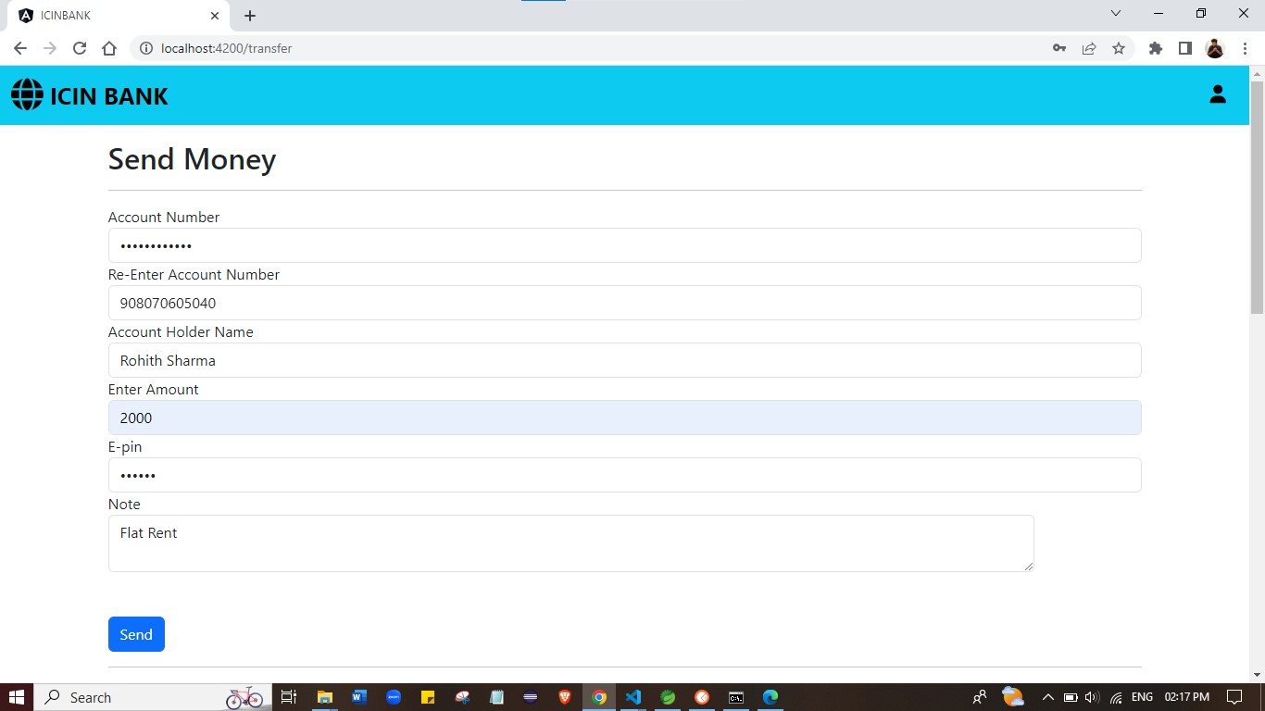

Deposit :
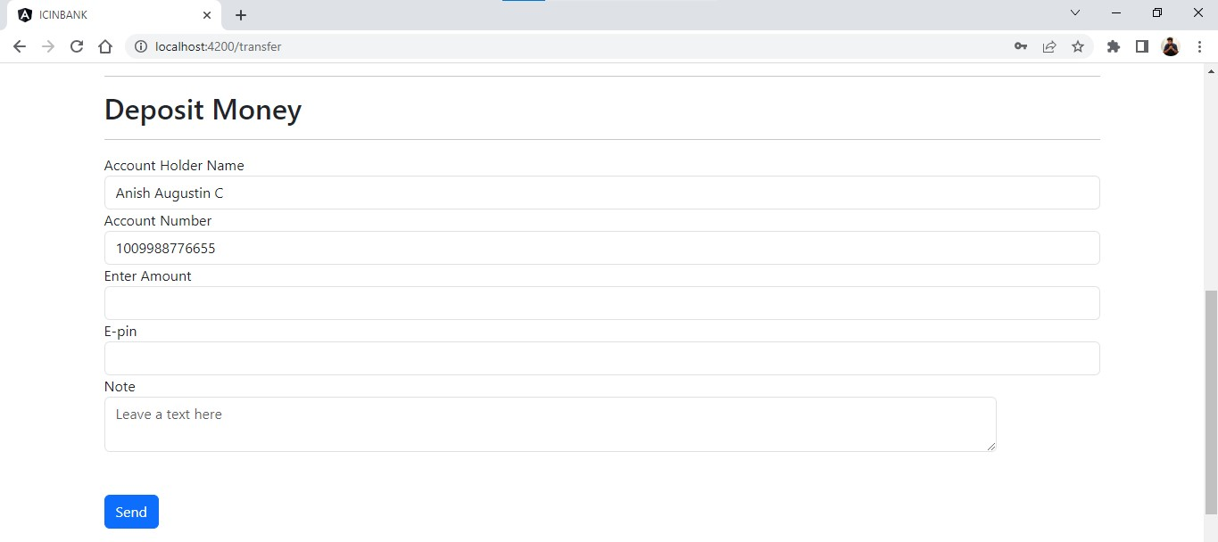

Withdraw Money :
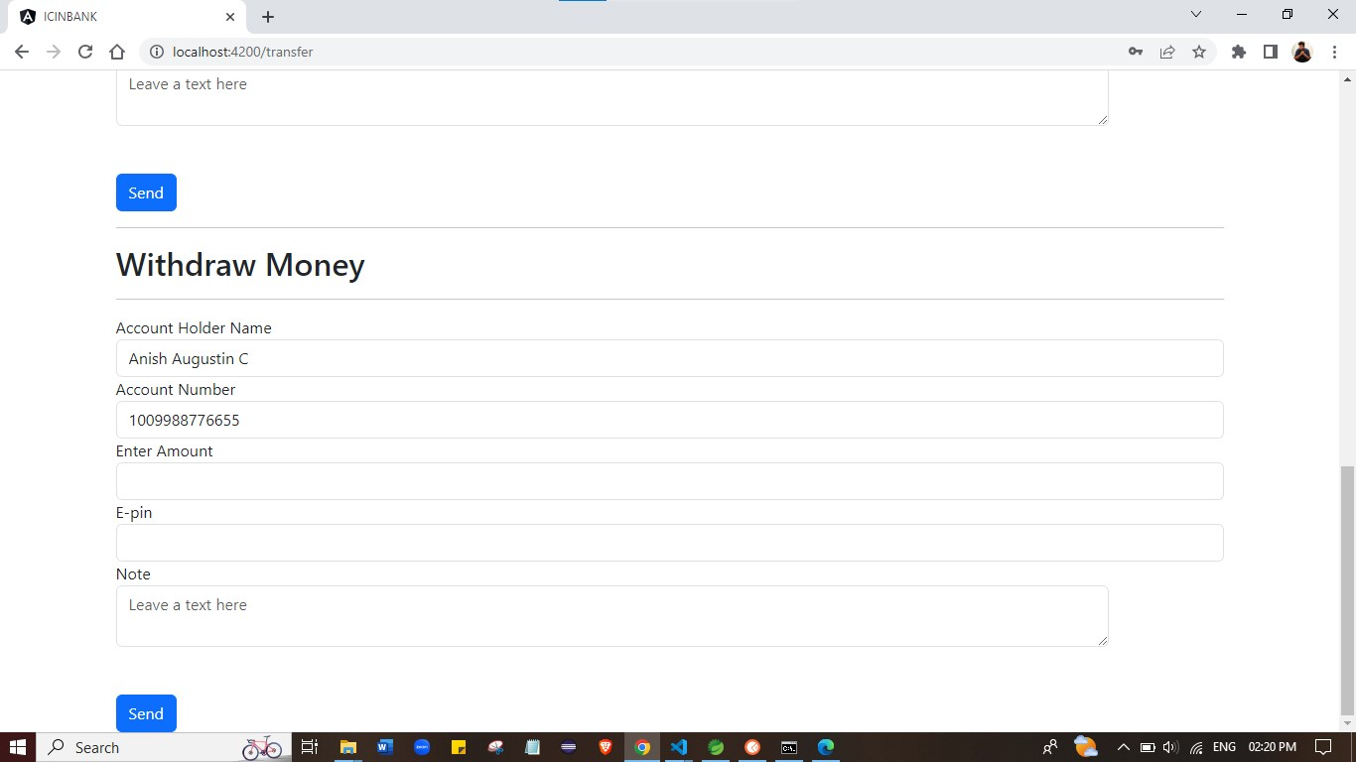

Request :
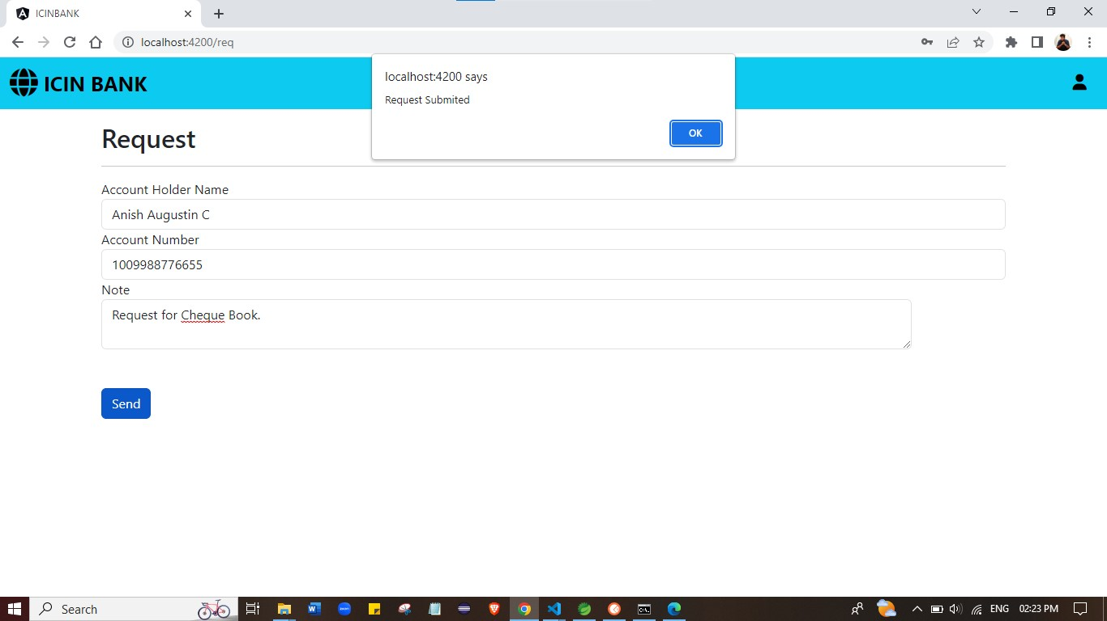

Admin Login :
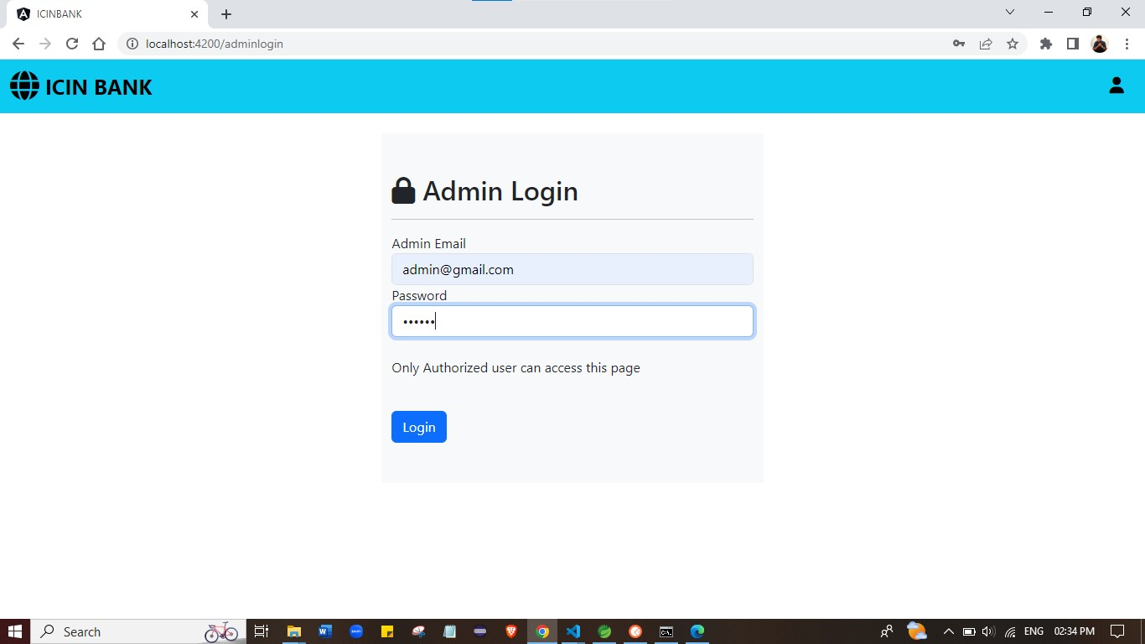

Admin Dashboard:
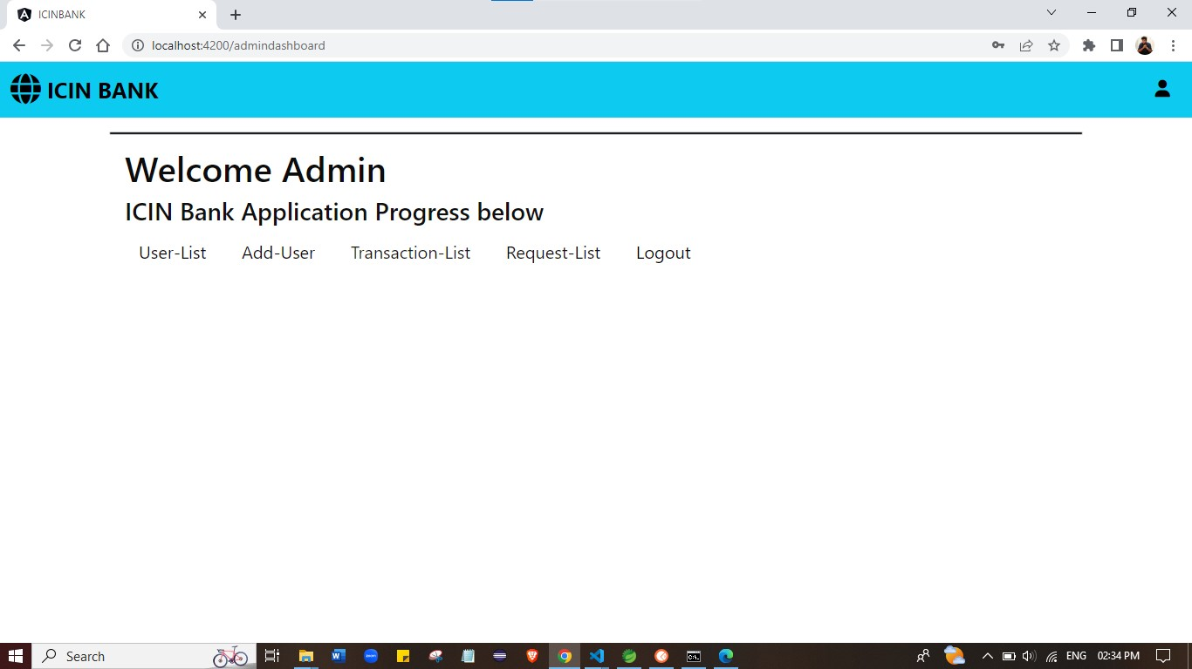

User-List
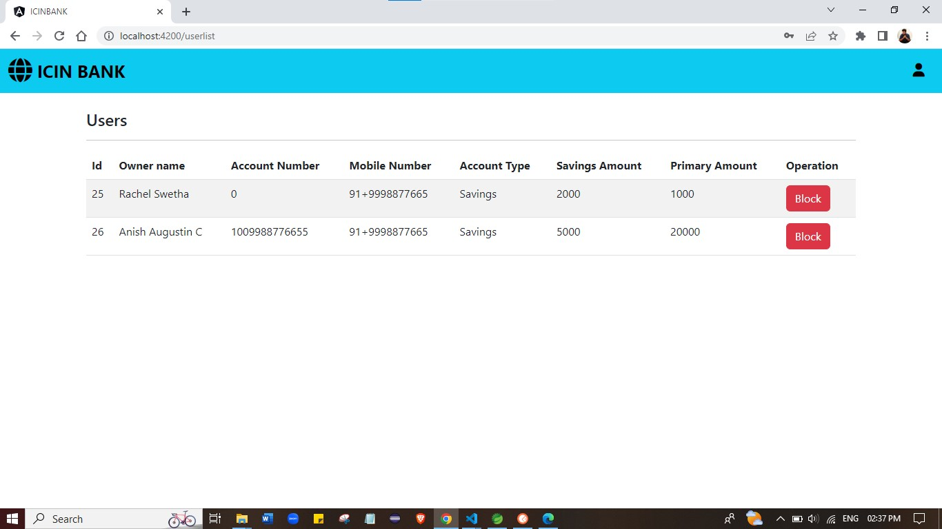

Transaction-List :
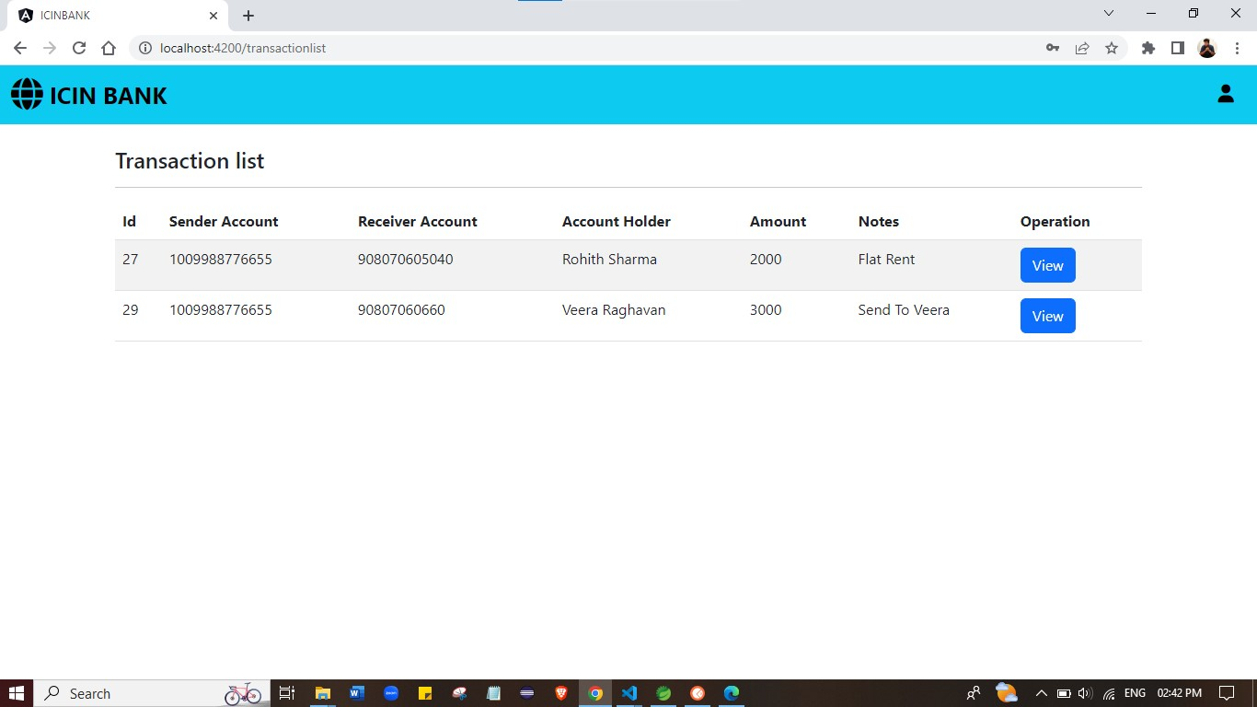

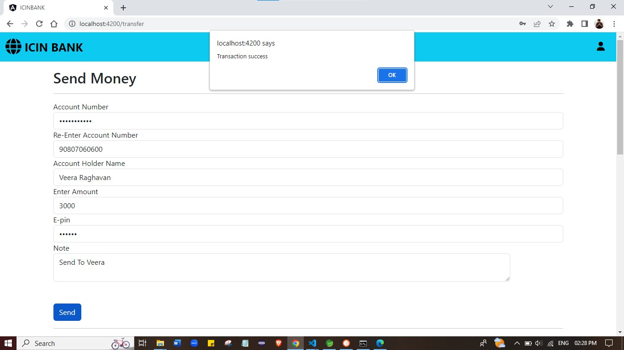

Request -List :
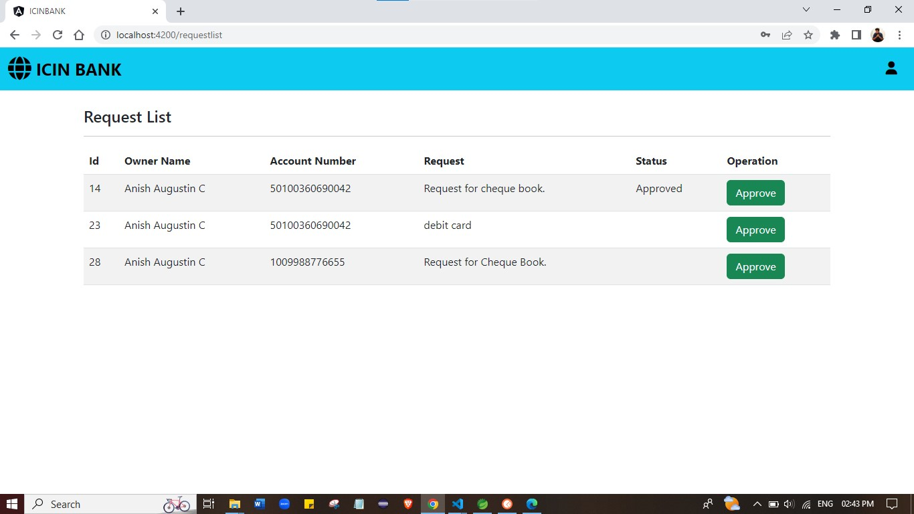

Request Update :
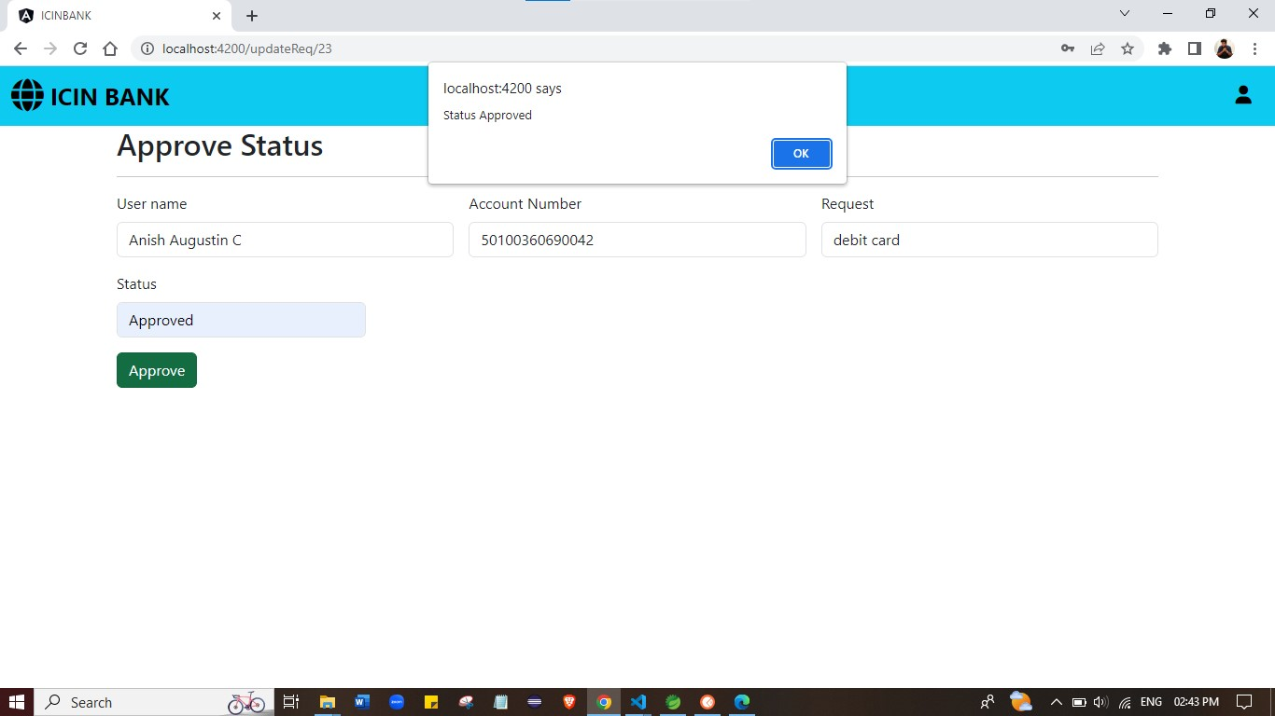

Block User :
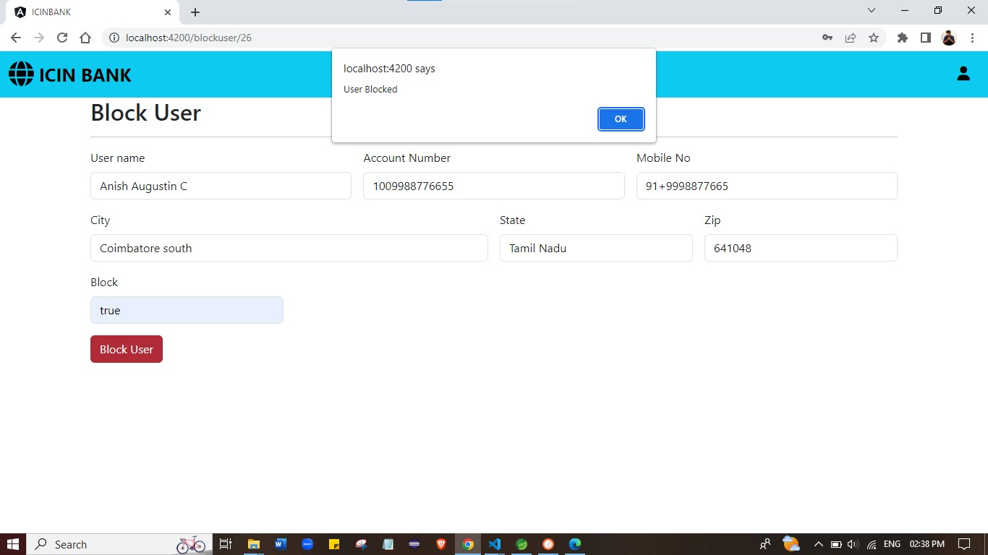

Blocked :
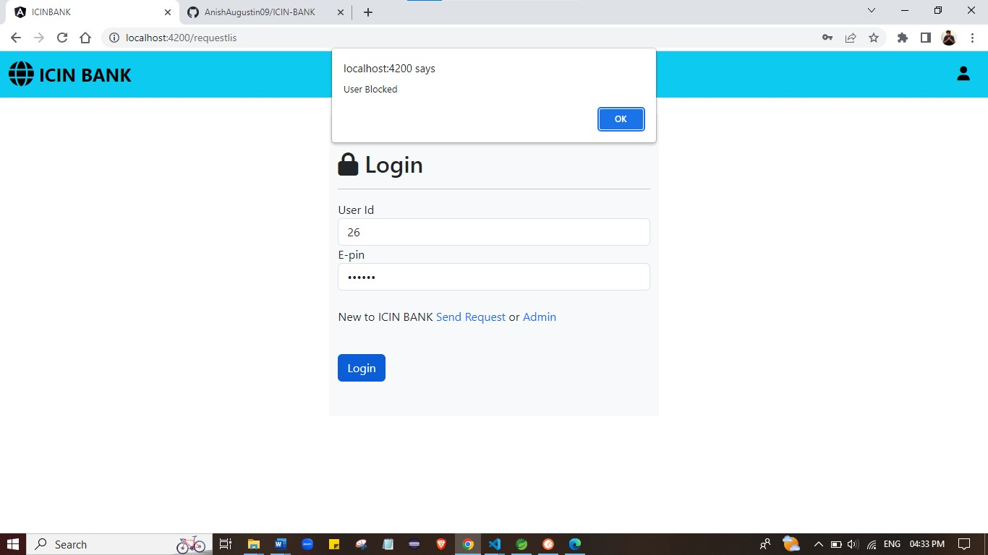

FINAL SETTING : Upload files to GitHub Repository
- Open your command prompt and navigate to the folder where you have created your files.
- cd <folder path>
- Initialize repository using the following command:
- git init
- Add all the files to your git repository using the following command:
- git add .
- Commit the changes using the following command:
- git commit . -m <commit message>
- Push the files to the folder you initially created using the following command:
- git push -u origin master

Unique Selling Points:
- This application is use to store & manage the Company products, users & Purchase Record
- This application will keep on running until user close the program.
- It allows the admin to add, update , delete, for the products, Users & Purchase Record.
- It allows the admin to Update Password, Search Reports by date and Category & Search user by email.
Conclusion:
Further enhancements to the application can be made which may include
To deliver better Front-end.

THANK YOU

